|  |  |  |  |
| --- | --- | --- | --- |
| *Agnel Charities*  **Fr. C. Rodrigues Institute of Technology, Vashi**  **Department of Electronics and Telecommunication Engg.**  **SUB:-Linux & Networking & Server Configuration ( LNSC) ECL-604** | | |  |
| **Configuration of FTP Server** | | |
| **EXPT NO** | **11** |  |
| **AIM** | **Configuration of FTP Server** | |
| **THEORY** | vsftpd, (or very secure **FTP** daemon), is an FTP server for Unix-like systems, including Linux. It is the default FTP server in the Ubuntu, CentOS, Fedora, NimbleX, Slackware and RHEL Linux distributions.  **To set up a sftp server on Ubuntu using SSH, you can follow these steps:**  SSH, also known as **Secure Shell or Secure Socket Shell**, is a network protocol that gives users, particularly system administrators, a secure way to access a computer over an unsecured network. SSH also refers to the suite of utilities that implement the SSH protocol. SFTP runs over an SSH session, usually on TCP port 22.  **FTP (file transfer protocol)** is an internet protocol that is used for transferring files between client and server over the internet or a computer network. It is like other internet protocols like SMTP which is used for emails and HTTP which is used for websites. **FTP server** enables the functionality of transferring files between server and client. A **client**connects to the **server**with credentials and depending upon the permissions it has, it can either read files or upload files to the server as well. In this article, we will see how to set up an FTP server, configure user permissions, configure firewall and finally encrypt our FTP traffic with SSL.  FTP server facilitates the transfer of files between client and server. You can either upload a file to a server or download a file from the server. A client makes two types of connection with the server, one for giving commands and one for transferring data. The client issues the command to the FTP server on port 21, which is the command port for FTP. For transferring data, a data port is used. There are two types of connection modes for transferring data:   * Active mode: In Active mode, the client opens a port and waits for the server to connect to it to transfer data. The server uses its port 20 to connect to the client for data transfer. Active mode is not set by default in most of the FTP clients because most firewalls * **To set up a sftp server on Ubuntu using SSH, you can follow these steps:** block the connections which are initiated from outside, in this case, the connection initiated by our FTP server. To use this, you must configure your firewall. * Passive mode:  In this, when a client requests a file from the server, the server opens a random port and tells the client to connect to that port. In this case, the connections are initiated by the client, and this also solves the firewall issues. Most of the FTP clients use passive mode by default. * Ftp file transfer protocol , sftp=secured ftp, csftp=very secured ftp | |
| **PROCEDURE** | 1. **Be Su , and do Update and install ssh server**   # apt update  # apt upgrade  # apt install ssh   1. **Enable ssh service: Sftp service depend on SSH(** SSH or Secure Shell is a network communication protocol that **enables two computers to communicate,**   SFTP cannot exist without SSH — **SFTP uses SSH as the binding agent to transfer files securely**. In other words, SSH protocol is used in the file transfer mechanism SFTP. In fact, most SSH servers include SFTP capabilities. Security: **SSH provides the highest level of security**, with encryption and authentication built into the protocol. By default, SFTP uses SSH's default port - port 22 **for authentication,control, and data transfer**. )  # systemctl enable ssh  # systemctl start ssh  # systemctl status ssh   1. **Add groups and directories for server**   # addgroup sftp  # adduser yc  enter username and password for the user yc( let the password be ‘ yc ‘)   1. **Give the necessary permissions for the user**   **Add** USERNAME yc to sftp group  # usermod -a -G sftp yc  Verify sftp group details  #grep sftp /etc/group  Observe username yc as member of sftp group  Create a directory that user can access.  # mkdir -p /var/sftp/Files  Give the ownershipof sftp to the root user  # chown root:root /var/sftp  Change the access permission  # chmod 755 /var/sftp   1. **Setup the SSH config file**   # nano /etc/ssh/sshd_config  type at the ending of file following lines:  Match user yc  ChrootDirectory /var/sftp  X11Forwarding no  AllowTcpForwarding no  ForceCommand internal-sftp  **Save and exit**   1. **Restart ssh**   # systemctl restart ssh  # systemctl status ssh  Observe status should be active   1. **Install open source ftp client tool winscp (open source install it on windows machine) or filezilla (on Linux machine) on your machine.**   **WinSCP is an open source free SFTP client, FTP client, WebDAV client, S3 client and SCP client and file manager for Windows. Its main function is file transfer between a local and a remote computer. Beyond this, WinSCP offers scripting and basic file manager functionality.** [**https://winscp.net/eng/docs/introduction**](https://winscp.net/eng/docs/introduction)**.**  **When sftp/vsftpd server is set up and ready to use , you can connect to it using an FTP client such as FileZilla, using the IP address or domain name of your server, and the username and password you created on ubuntu server machine.**   1. **Put ip address I host name place , username as yc , password as yc and port number 21( default for sssh’s sftp) in the software window**   **C:\Users\admin\Downloads\WhatsApp Image 2023-03-20 at 8.01.45 PM (1).jpeg**  **Check the functionality by adding files on both linux and windows.**   1. **Stop the service and check transfer.**   **#** systemctl stop ssh   1. **Restart the service and check the access.** | |
| **OUTPUTS** | C:\Users\admin\Downloads\WhatsApp Image 2023-03-20 at 8.19.04 PM.jpeg | |
| **CONCLUSION** | In this Practical we learned how to install and enable FTP Server on an Ubuntu. By following above steps, you should have installed an FTP server on Ubuntu with sftpd. You should now be able to configure your user lists and accounts and connect to your new FTP server. | |

Practice :

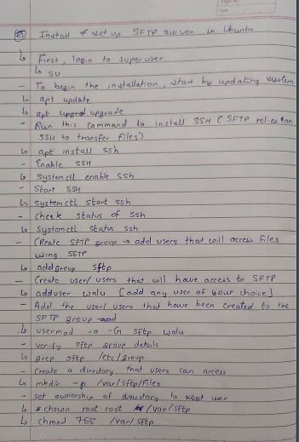

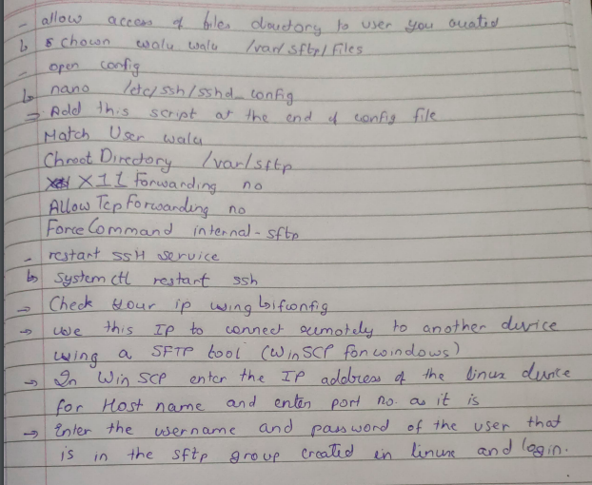

Yo